Edmonston Treasure Hunt

Kindergarten to 3rd graders

To complete this treasure hunt, go around the town and find information signs. Answer all the questions and email a copy to townhall@edmonstonmd.gov to win a backpack and school supplies

Go the Edmonston Recreation Center, 5100 Tanglewood Dr, Edmonston, MD 20781.

What is a pollinator garden?

Name 2 pollinator insects.

Bonus: What is a habitat?

Visit Crittenden Street and look for two signs.

Fill in the blank:

A green street redirects ___________ in a safe way to prevent flooding.

2. What are native plants? Name 2 plants.

3. How do rain gardens help the environment?

Go to ECO City Farms, 4913 Crittenden St, Edmonston, MD 20781.

1. Fill in the blank:

ECO City farms practices _________ farming.

Who were the first farmers in Edmonston?

Who is Adam Plummer?

Bonus: When was ECO City farms founded?

Go to Edmonston Town Hall, 5005 52nd Avenue

1. Name 2 pollinators are attracted to rain gardens.

Bring your completed treasure hunt to Town Hall or email us and get your FREE backpack and school supplies!

5005 52nd Avenue

Edmonston, MD 20781

townhall@edmonstonmd.gov

301-699-8806

Edmonston Treasure Hunt
For 4th to 6th graders
The Town of Edmonston history begins in 1742 when Captain James Edmonston bought 60 acres of land along the Anacostia River. The town has a focus on being sustainable and eco-friendly. Some things Edmonston has done to be environmentally friendly is plant rain gardens, pollinator gardens, build a green street with permeable pavement, and hosted plenty of environmental events. To complete this treasure hunt, go around the town and find information signs. Answer all the questions and email a copy to townhall@edmonstonmd.gov to backpack and school supplies! Everyone can win, if you try to complete the treasure hunt and learn something new about the small town of Edmonston.

Go the Edmonston Recreation Center, 5100 Tanglewood Dr, Edmonston, MD 20781
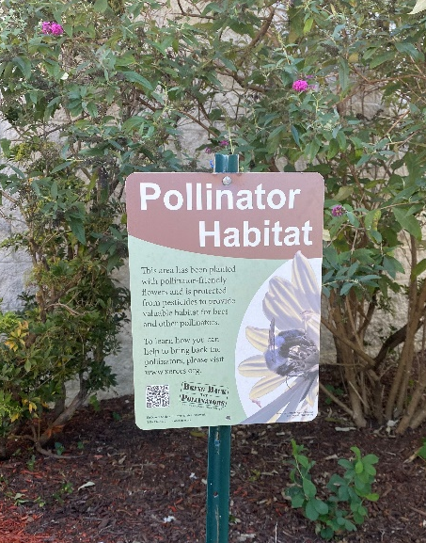
- Name 2 pollinator insects.

- What is a pollinator habitat?

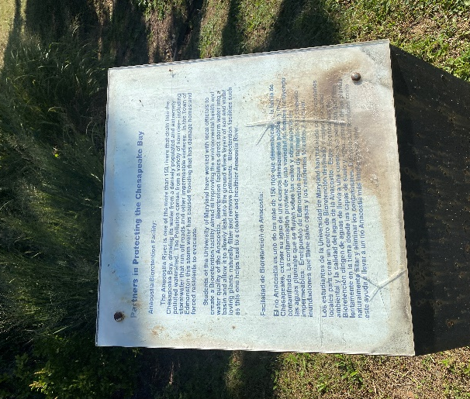
- How many rivers flow into the Chesapeake Bay?

- What problem did Edmonston have with stormwater?

Visit Crittenden Street and look for two signs.
- Fill the blank: Crittenden is the second ________ street in Edmonston.

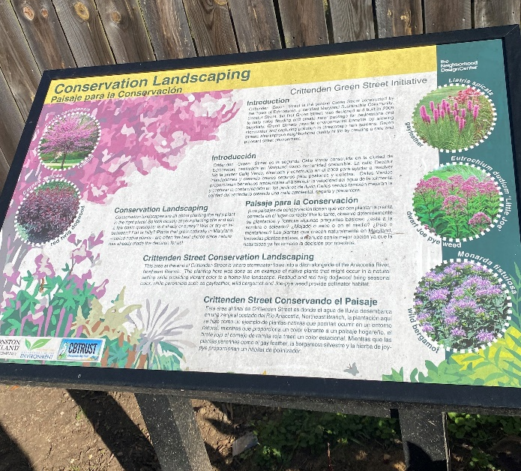

- What is conservation landscaping?

- What are some qualities you look for in conservation landscaping?

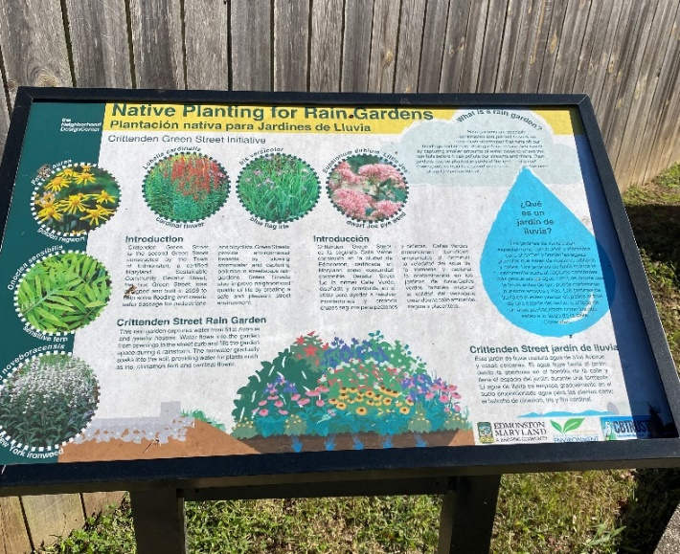
- What is a rain garden made for?

- List some native plants that can be included in a rain garden.

Go to ECO City Farms, 4913 Crittenden St, Edmonston, MD 20781.
- What does ECO City Farms do for the community?
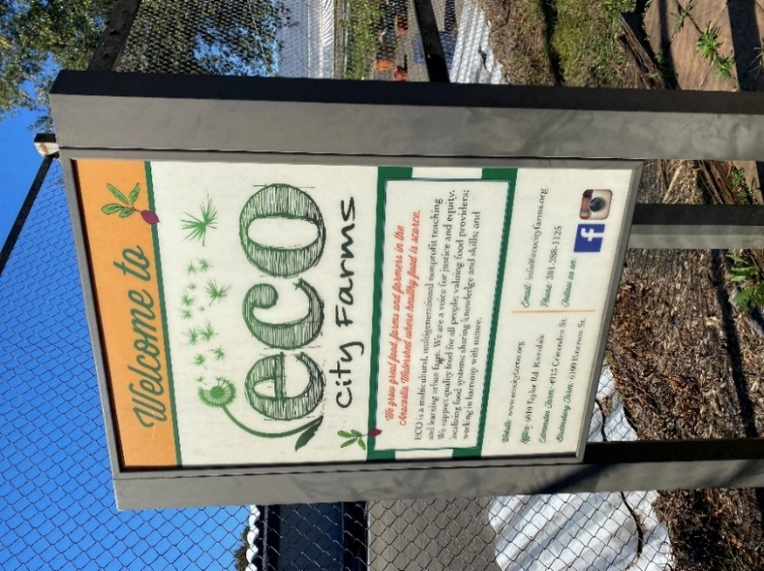

- Who is Adam Francis Plummer?

- When was ECO City farms founded?

Visit Decatur Street and find this sign.
- What are the six parts of a green street?

- Why did Edmonston create a green street?

- Bonus: The green street includes environmental practices like a tree canopy and an underground stormwater system. What is a tree canopy?
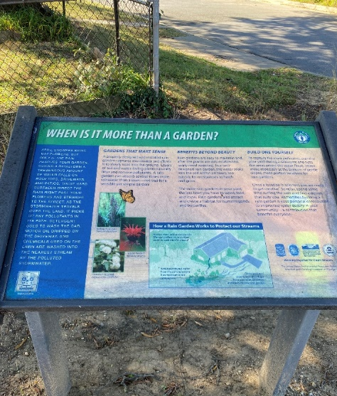
Finally, visit Edmonston Town Hall, 5005 52nd Avenue
- Rain gardens absorbs stormwater after heavy rainfall. How can stormwater be bad?

- List 3 good things about rain gardens.

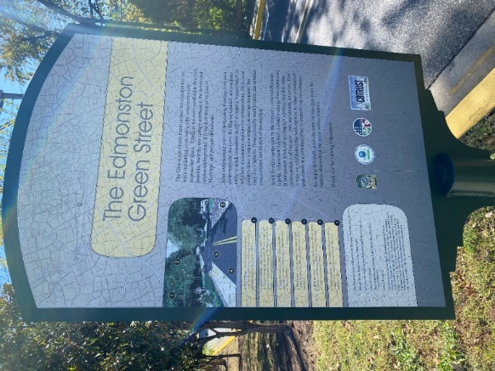

Thank you for completing the Edmonston Treasure Hunt! We hope you learned something during your treasure hunt adventure. Once you are finished with the treasure hunt, bring it to Town Hall, or email us townhall@edmonstonmd.gov, to pick up your free backpack and school supplies!

Contact the Town of Edmonston for any questions.

5005 52nd Avenue

Edmonston, MD 20781

townhall@edmonstonmd.gov

301-699-8806

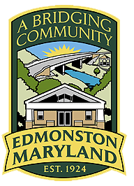

Edmonston Treasure Hunt
For 7th Graders and Up

The Town of Edmonston history starts in 1742 when Captain James Edmonston bought 60 acres of land along the Anacostia River. The town has a focus on being sustainable and eco-friendly. To complete this treasure hunt, go around the town and find information signs. Answer all the questions and email a copy to townhall@edmonstonmd.gov to win a backpack and school supplies! Everyone can win, if you try to complete the treasure hunt and learn something new about the small town of Edmonston.

Go the Edmonston Recreation Center, 5100 Tanglewood Dr, Hyattsville, MD 20781 and find the signs.
- What is a pollinator garden? What is the purpose of it?

- How many rivers flow into the Chesapeake Bay?

- What are some problems with stormwater?

- Describe a bioretention facility. What’s the purpose?
Visit Crittenden Street and look for two signs.
- Crittenden is the second green street in Edmonston. What are green streets?

- Define conservation landscaping.

- What are native plants?

- What is a rain garden? How does it help the environment?

- List some native plants that can be included in a rain garden.

Visit 4900 Block of 51st Place and look for one sign.
- What are some reasons to have a green street?

- Where was the first green street in Edmonston?

- What changes to landscape has been made to 51st Place?

Go to ECO City Farms, 4913 Crittenden St, Hyattsville, MD 20781.
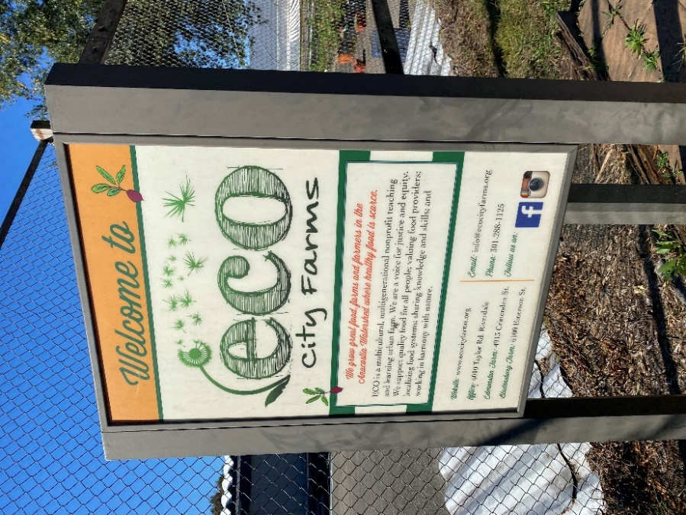
- Historically, who were the first residents at Edmonston?

- What was the main crop planted along the Anacostia River?

- Who is Adam Francis Plummer?

- What happened to the Palestine dairy farm?

- When was ECO City farms founded? What’s the purpose of the farm?

Take a moment to view Decatur Street Bridge, the bridge that connects the east and west of the town.
- List 5 country flags on the memorial.

- Visit the Art in the Park near the gazebo. What is your favorite art piece and why?

- Feel free to enjoy the Anacostia River Trail along veteran’s park.

Visit Decatur Street, signs are located between Kenilworth Avenue and the railroad tracks.
- What are the six aspects of a green street?

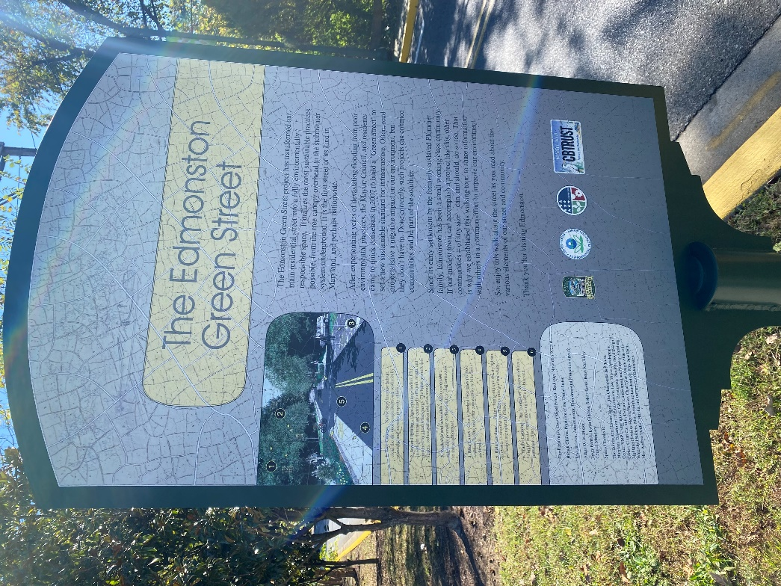
- Flooding is the main reason Edmonston created a green street. How do green streets prevent flooding? Give two examples.

- How did the green street boost the economy? Give two examples.

- How does the Town of Edmonston save energy?

- What is clean energy? How is it different from burning fossil fuels or coal?

- List three things Adam Francis Plummer and his family accomplished.

- What is permeable pavement? How is it different from normal pavement?

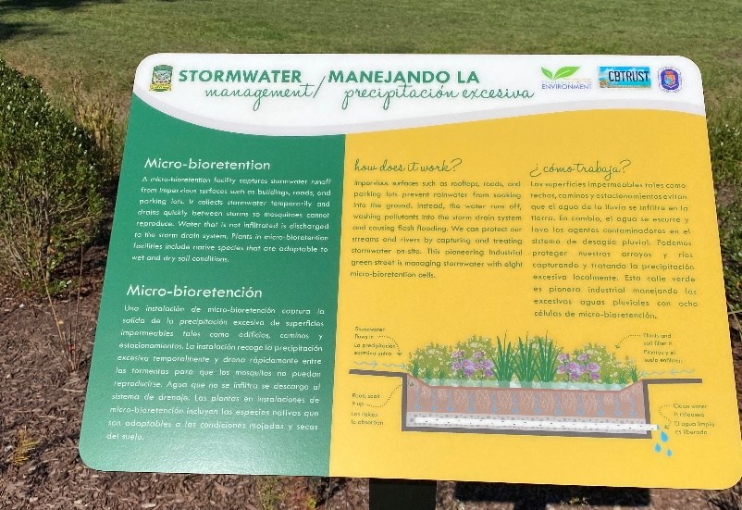
- How does rainwater cause flooding and spread of pollution?

Visit 4600 Block of Ingraham Street.
- Give an example of a micro-bioretention facility.

- Describe the problem that bioretention facilities solve.

Finally, go to Edmonston Town Hall, find one sign, and submit your treasure hunt for a prize!
- How do rain gardens lower mosquito populations?

- List a few pollinators that are attracted to rain gardens.

Thank you for completing the Edmonston Treasure Hunt! We hope you learned something during your treasure hunt adventure. The Town of Edmonston is full of charm, ambition, we are a town that continues to grow and change. Once you are finished with the treasure hunt, bring it to Town Hall, or email us to collect your free backpack and school supplies

Contact the Town of Edmonston for any questions.

5005 52nd Avenue
Edmonston, MD 20781
townhall@edmonstonmd.gov
301-699-8806

